EE113D: Digital Signal Processing Design

Lab 4: Digital Filtering on the H7

**OBJECTIVE**

The objective of this lab is to analyze the frequency response of signals generated using the AD2 and the H7 board. Signals generated with the H7 apply a low pass filter through software with the CUBE IDE and MATLAB.

**DISCUSSION**

I measured the frequency response by recording the ratio of AC RMS values of the output signal to the input signal. Then, I convert the amplitude in decibel scale, which I then plot by frequency in logarithmic scale. For part 1b, due to the frequency warping effect of the bilinear transformation for discrete samples, the expected behavior of the bode plots differ from the measured values. This effect is a result of the difference in the frequency mapping between continuous and discrete angular frequencies on the s-plane and z-plane, respectively. Hence, inverse frequency mapping is applied to ensure that the expected frequency drop-offs match the actual frequency drop-offs in the filtered signal.

**PART 1**

Figure 1. Frequency response of the H7 output signal without filtering.

|  |  |  |  |  |  |  |  |
| --- | --- | --- | --- | --- | --- | --- | --- |
| Test Frequencies for 1KHz LPF | | | | | | | |
| Frequency (Hz) | 100 | 200 | 500 | 1000 | 2000 | 5000 | 10000 |
| Part 1a Gain (dB) | 0.06585 | 0.07353 | 0.05915 | -0.07355 | -0.05843 | -0.23232 | -0.20896 |
| 1KHz LPF Vo/Vi (dB) | 0.10063 | 0.23389 | 1.08949 | -3.05989 | -6.42827 | -14.5557 | -21.5874 |
| 1KHz LPF Gain (dB) | 0.03478 | 0.16035 | 1.03034 | -2.98634 | -6.36984 | -14.3233 | -21.3784 |

Table 1. H7 signal frequency response with a 1KHz LPF filter applied through bilinear transformation.

Figure 2. H7 signal frequency response with a 1KHz LPF filter applied through bilinear transformation.

|  |  |  |  |  |  |  |
| --- | --- | --- | --- | --- | --- | --- |
| Test Frequencies for 20KHz LPF | | | | | | |
| Frequency (Hz) | 1000 | 2000 | 5000 | 10000 | 14000 | 20000 |
| Part 1a Gain (dB) | 0.70566 | 0.7055 | 0.70512 | 0.70509 | 0.70527 | 0.70523 |
| 20KHz LPF Vo/Vi (dB) | -0.05148 | -0.04308 | -0.09424 | -0.39181 | -0.81942 | -3.37877 |
| 20KHz LPF Gain (dB) | 0.02207 | 0.015354 | 0.138086 | -0.18285 | -0.48395 | -2.89831 |

Table 2. H7 signal frequency response with a 20KHz LPF filter applied through bilinear transformation.

Figure 3. H7 signal frequency response with a 20KHz LPF filter applied through bilinear transformation.

CODE:

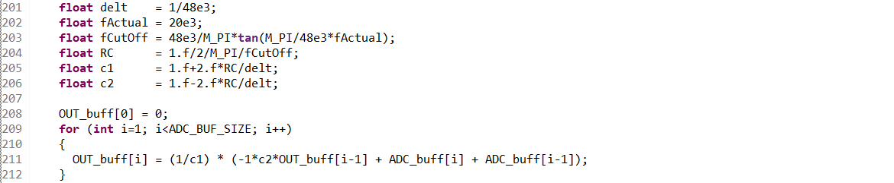

**PART 2**

|  |  |  |  |  |  |  |  |
| --- | --- | --- | --- | --- | --- | --- | --- |
| Test Frequencies for ~1KHz LPF | | | | | | | |
| Frequency (Hz) | 100 | 200 | 500 | 1000 | 2000 | 5000 | 10000 |
| Part 1a Gain (dB) | 0.06585 | 0.07353 | 0.05915 | -0.07355 | -0.05843 | -0.23232 | -0.20896 |
| 1KHz LPF Vo/Vi (dB) | 0.025552 | 0.01921 | 0.37409 | -1.94667 | -18.0158 | -25.9072 | -32.3718 |
| 1KHz LPF Gain (dB) | 0.091398 | 0.054321 | 0.31494 | -1.87312 | -17.9574 | -25.6749 | -32.1628 |

Table 3. H7 signal frequency response with a 1KHz IIR LPF filter.

Figure 4. H7 signal frequency response with a 1KHz IIR LPF filter.

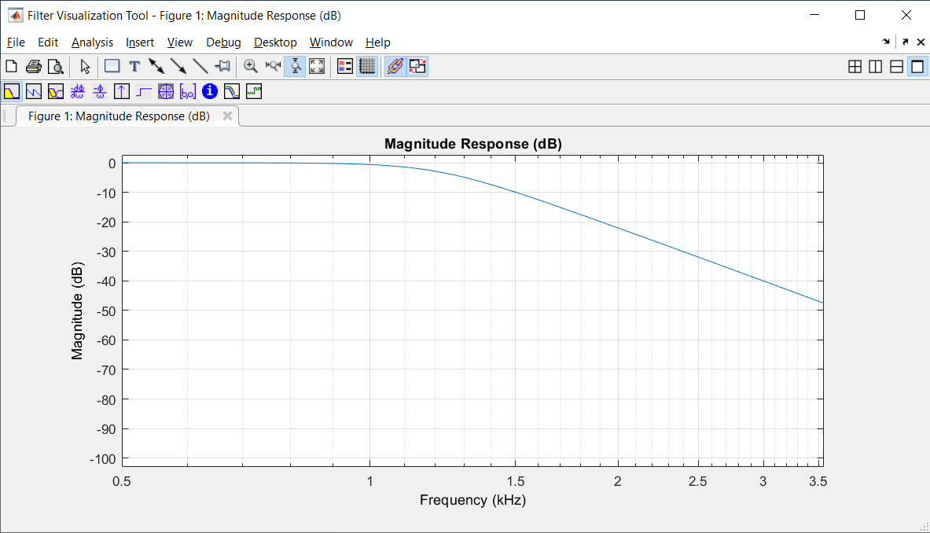

Figure 5. Magnitude response of the IIR LPF.

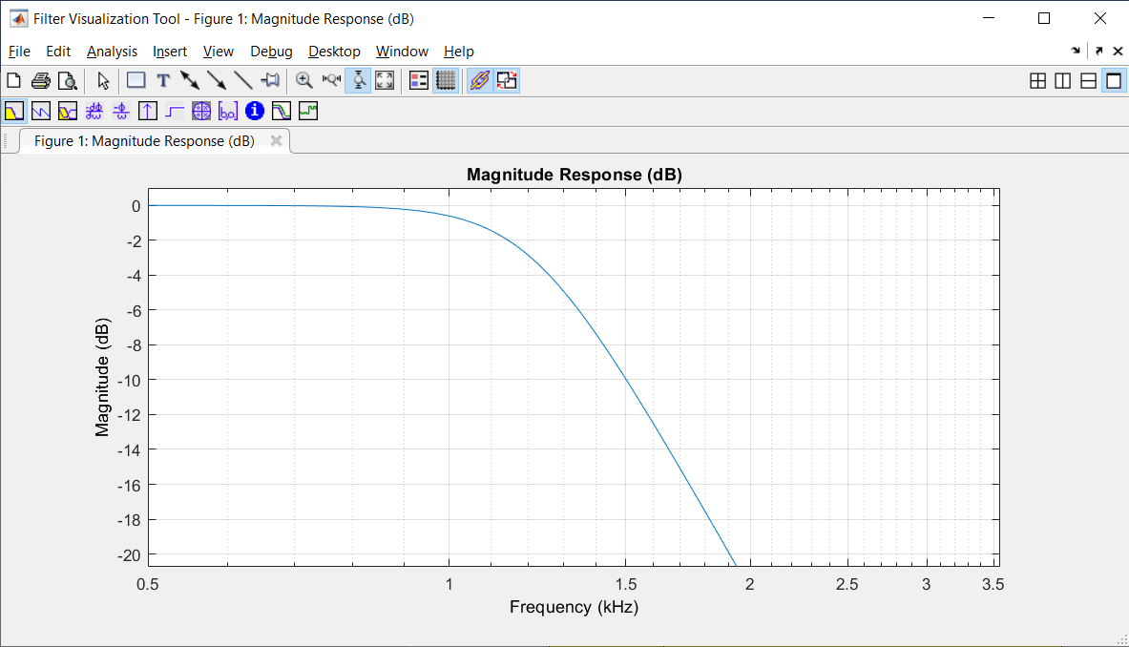

Figure 6. Zoomed in magnitude response of the IIR LPF. The -3dB drop-off occurs at ~1.2KHz

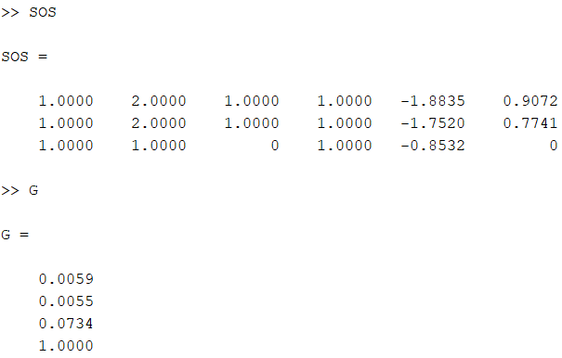

Figure 7. Screenshot of the second-order section and gain section coefficients.